# Second Year B. Tech (EL & CE)

**Semester: IV Subject:** Basic IoT Laboratory

**Name: Shreerang Mhatre Class: SY**

**Roll No: 29 Batch: A2**

# Experiment No: 03

**Name of the Experiment**: Interfacing stepper motor/DC Motor and relay with hardware platforms.

**Performed on:**

**Teacher’s Signature with date**

|  |
| --- |
| **Marks** |
|  |
|  |

**Submitted on:**

**Aim:** Interfacing of Actuators with hardware platforms

**Prerequisite:** Arduino board, Arduino IDE, Basics of Actuators.

# Objectives:

1. To understand usefulness of Actuators
2. To understand Actuators specification, working and applications
3. To get the output using actuator and interface with Arduino Uno
4. To understand and experience PWM concept with Arduino Uno.

# Components and equipment required:

Arduino Uno Board, USB cable, Arduino IDE, 5V DC motor, 270Ω Resistor, BC548 NPN transistor, 1N4001 Diode, Bread board, Jumper wires, 10k Ω Potentiometer, Push button and L293D Motor Driver IC, etc.

# Theory:

DC motors are electric motors that are powered by direct current (DC), such as from a battery or DC power supply. Their commutation can be brushed or brushless. The speed of a brushed DC motor can be controlled by changing the voltage alone. This makes DC motors better suited for equipment ranging from 12VDC systems in automobiles to conveyor motors, both which require fine speed control for a range of speeds above and below the rated speeds.

DC motor basically consists of two main parts. The rotating part is called the rotor and the stationary part is also called the stator. The rotor rotates with respect to the stator.

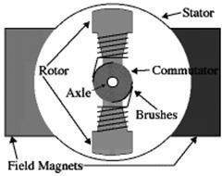

**Figure 3.1:** DC motor construction

The armature coil is the rotating part whereas the stationary part is the stator. In this, the armature coil is connected toward the DC supply which includes the brushes as well as the commutators. The main function of the commutator is to convert the AC to DC which is induced in the armature. The flow of current can be supplied by using the brush from the motor’s rotary part toward the inactive outside load. The arrangement of the armature can be done in between the two poles of the electromagnet or permanent.

# Working Principle

An electrical machine that is used to convert the energy from electrical to mechanical is known as a DC motor. The DC motor working principle is that when a current-carrying conductor is located within the magnetic field, then it experiences a mechanical force. This force direction can be decided through Flemming’s left-hand rule as well as its magnitude.

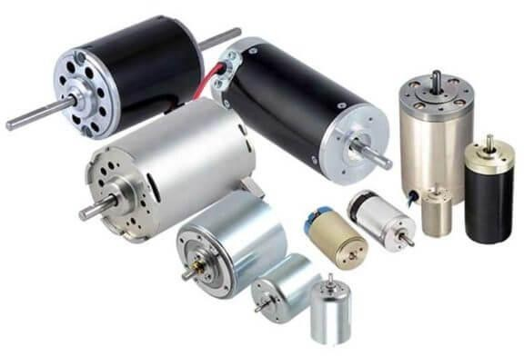

**Figure 3.2:** DC Motor

If the first finger is extended, the second finger, as well as the left hand’s thumb, will be vertical to each other & primary finger signifies the magnetic field’s direction, the next finger signifies the current direction & the third finger-like thumb signifies the force direction which is experienced through the conductor.

F = B*I*L Newtons

Where,

‘B’ is the magnetic flux density, ‘I’ is current

‘L’ is the conductor’s length in the magnetic field.

Whenever an armature winding is given toward a DC supply, then the flow of current will be set up within the winding. Field winding or permanent magnets will provide the magnetic field. So, armature conductors will experience a force because of the magnetic field based on the above-stated principle.

The Commutator is designed like sections to attain uni-directional torque or the path of force would have overturned each time once the way of the conductor’s movement is upturned within the magnetic field. So, this is the working principle of the DC motor. When selecting DC motors, industrial buyers need to identify the key performance specifications, determine design and size requirements, and consider the environmental requirements of their application.

**Shaft speed:** A DC motor applies a voltage (V) to rotate a shaft at a proportional rotational speed (ω). Shaft speed specs generally refer to the no-load speed, which is the maximum speed the motor can reach when no torque is applied. Typically, shaft speed is given in rotations or revolutions per minute (rpm). These rotations or revolutions can be related to the number of radians to express the motor speed in radians per second (rad/s). For numerical calculations, this unit of rotational speed is more convenient. The following formula describes the relationship between radians per second and rotations or revolutions per minute.

ω rad/s = ω rpm · (2π/60)

For an ideal DC motor, the rotational speed is proportional to the supplied voltage, or

ω = j · V

where j is the constant of proportionality, with units rad/(s-V).

**Circuit Connections**

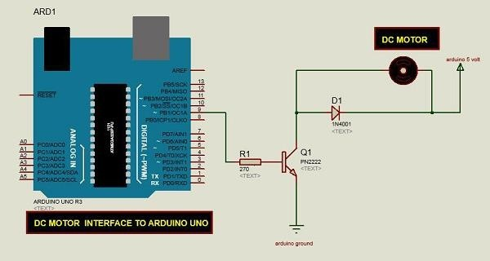

**Figure 3.3:** Schematic diagram of a DC motor, connected to the Arduino board.

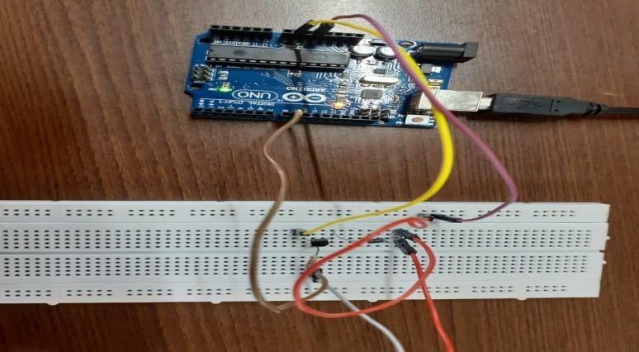

**Figure 3.4:** Arduino interfacing with Driver circuit implemented in lab

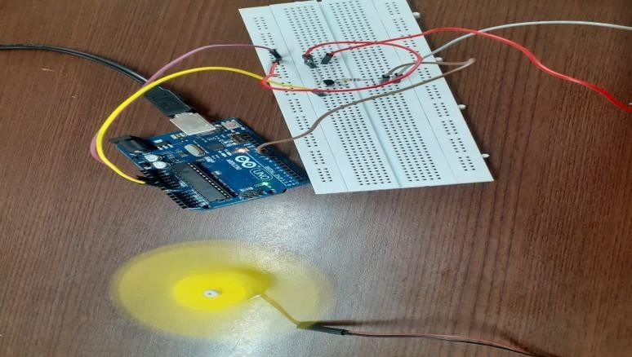

**Figure 3.5:** Arduino interfacing with Driver circuit and DC motor implemented

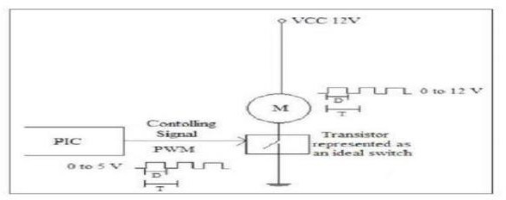

**Figure 3.6:** Speed control of DC motor Using PWM signal

**L293D Driver IC:**

In order to have a complete control over DC motor, we have to control its speed and rotation direction. This can be achieved by combining these two techniques.

PWM – For controlling speed

H-Bridge – For controlling rotation direction

The L293D is a dual-channel H-Bridge motor driver capable of driving a pair of DC motors or one stepper motor. That means it can individually drive up to two motors making it ideal for building two-wheel robot platforms.

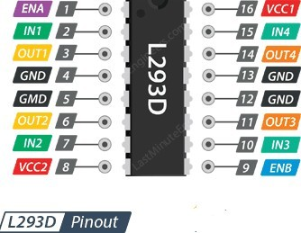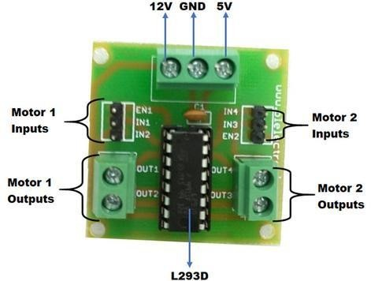

**Figure 3.7:** Pin Layout of L293D Motor Driver IC

**Circuit Connections**

* A button and a potentiometer are used to control the direction of rotation and speed of the motor
* A button is connected to Pin 12 of Arduino for driving the motor in forward and reverse direction with the other terminals of the button connected to GND.
* A potentiometer i.e. the wiper terminal of the pot is connected to analog input pin A0 of the Arduino UNO. The other terminals of the potentiometer are connected to 5V supply and ground
* Pin 1 of L293D IC is used to enable the driver channels 1 and 2 i.e. inputs of motor. It is an active high pin and hence it is connected to 5V supply.
* Pins 2 and 7 of L293D are inputs of drivers associated with motor 1. They are connected to Pins 11 and 10 of Arduino UNO respectively.
* Pins 3 and 6 of L293D are the output pins of first driver channel. They must be connected to the motor we are going to control.
* Pins 4, 5, 12 and 13 of the L293D IC are ground pins.
* Pin 16 of L293D IC is the supply pin for internal operations and is connected to a 5V supply.
* Pin 8 of L293D IC is the supply for driving the motor and is connected to a 5V supply.

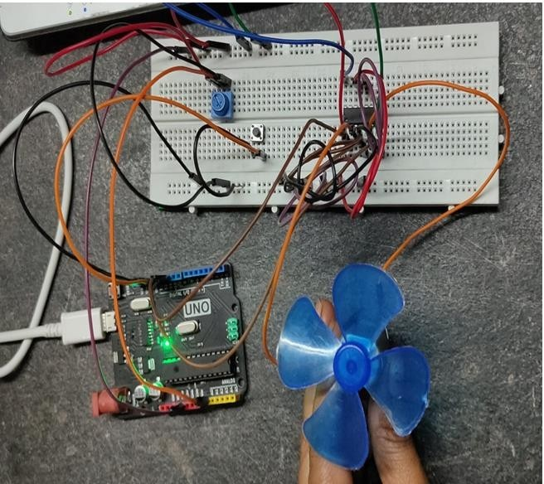

**Figure 3.8:** Direction and Speed control of DC Motor using L293D Motor Driver IC

# Conclusion:

**Post Lab Questions:**

1. List and state Different types of DC motor.
2. What is significance PWM? How to control speed using PWM pin? Explain in detail.
3. List out various Actuators used for IoT and explain anyone other than DC Motor.
4. What are different applications of DC motor? Explain any one in detail.

# Additional links for more information:

1. Introduction to Actuators <https://nptel.ac.in/content/storage2/courses/112104158/lecture36.pdf>
2. Arduino-DC Motor

<https://www.tutorialspoint.com/arduino/arduino_dc_motor.htm>

1. DC Motor Arduino Tutorial https://lastminuteengineers.com/l293d-dc-motor-arduino-tutorial/

**Expt. 3- 6**



